Power Automate to read from excel mail attachment

* Required for Oracle Db

1. Install 11 G Express edition

Please check services

Make sure odac for visual studio 2019 install

For establishment connection oracle db

**Attachment Read configuration details**



You can change the username and password.

As of now it will check every 5 minutes.

Calling for save the data into Orcale db

Attachment data

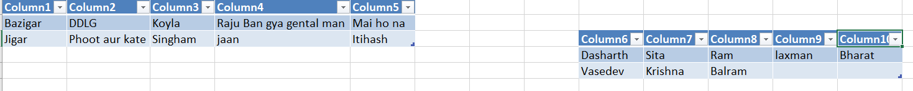

Db Records saved



After reading attachment content marking as read, so next time it will not read.

